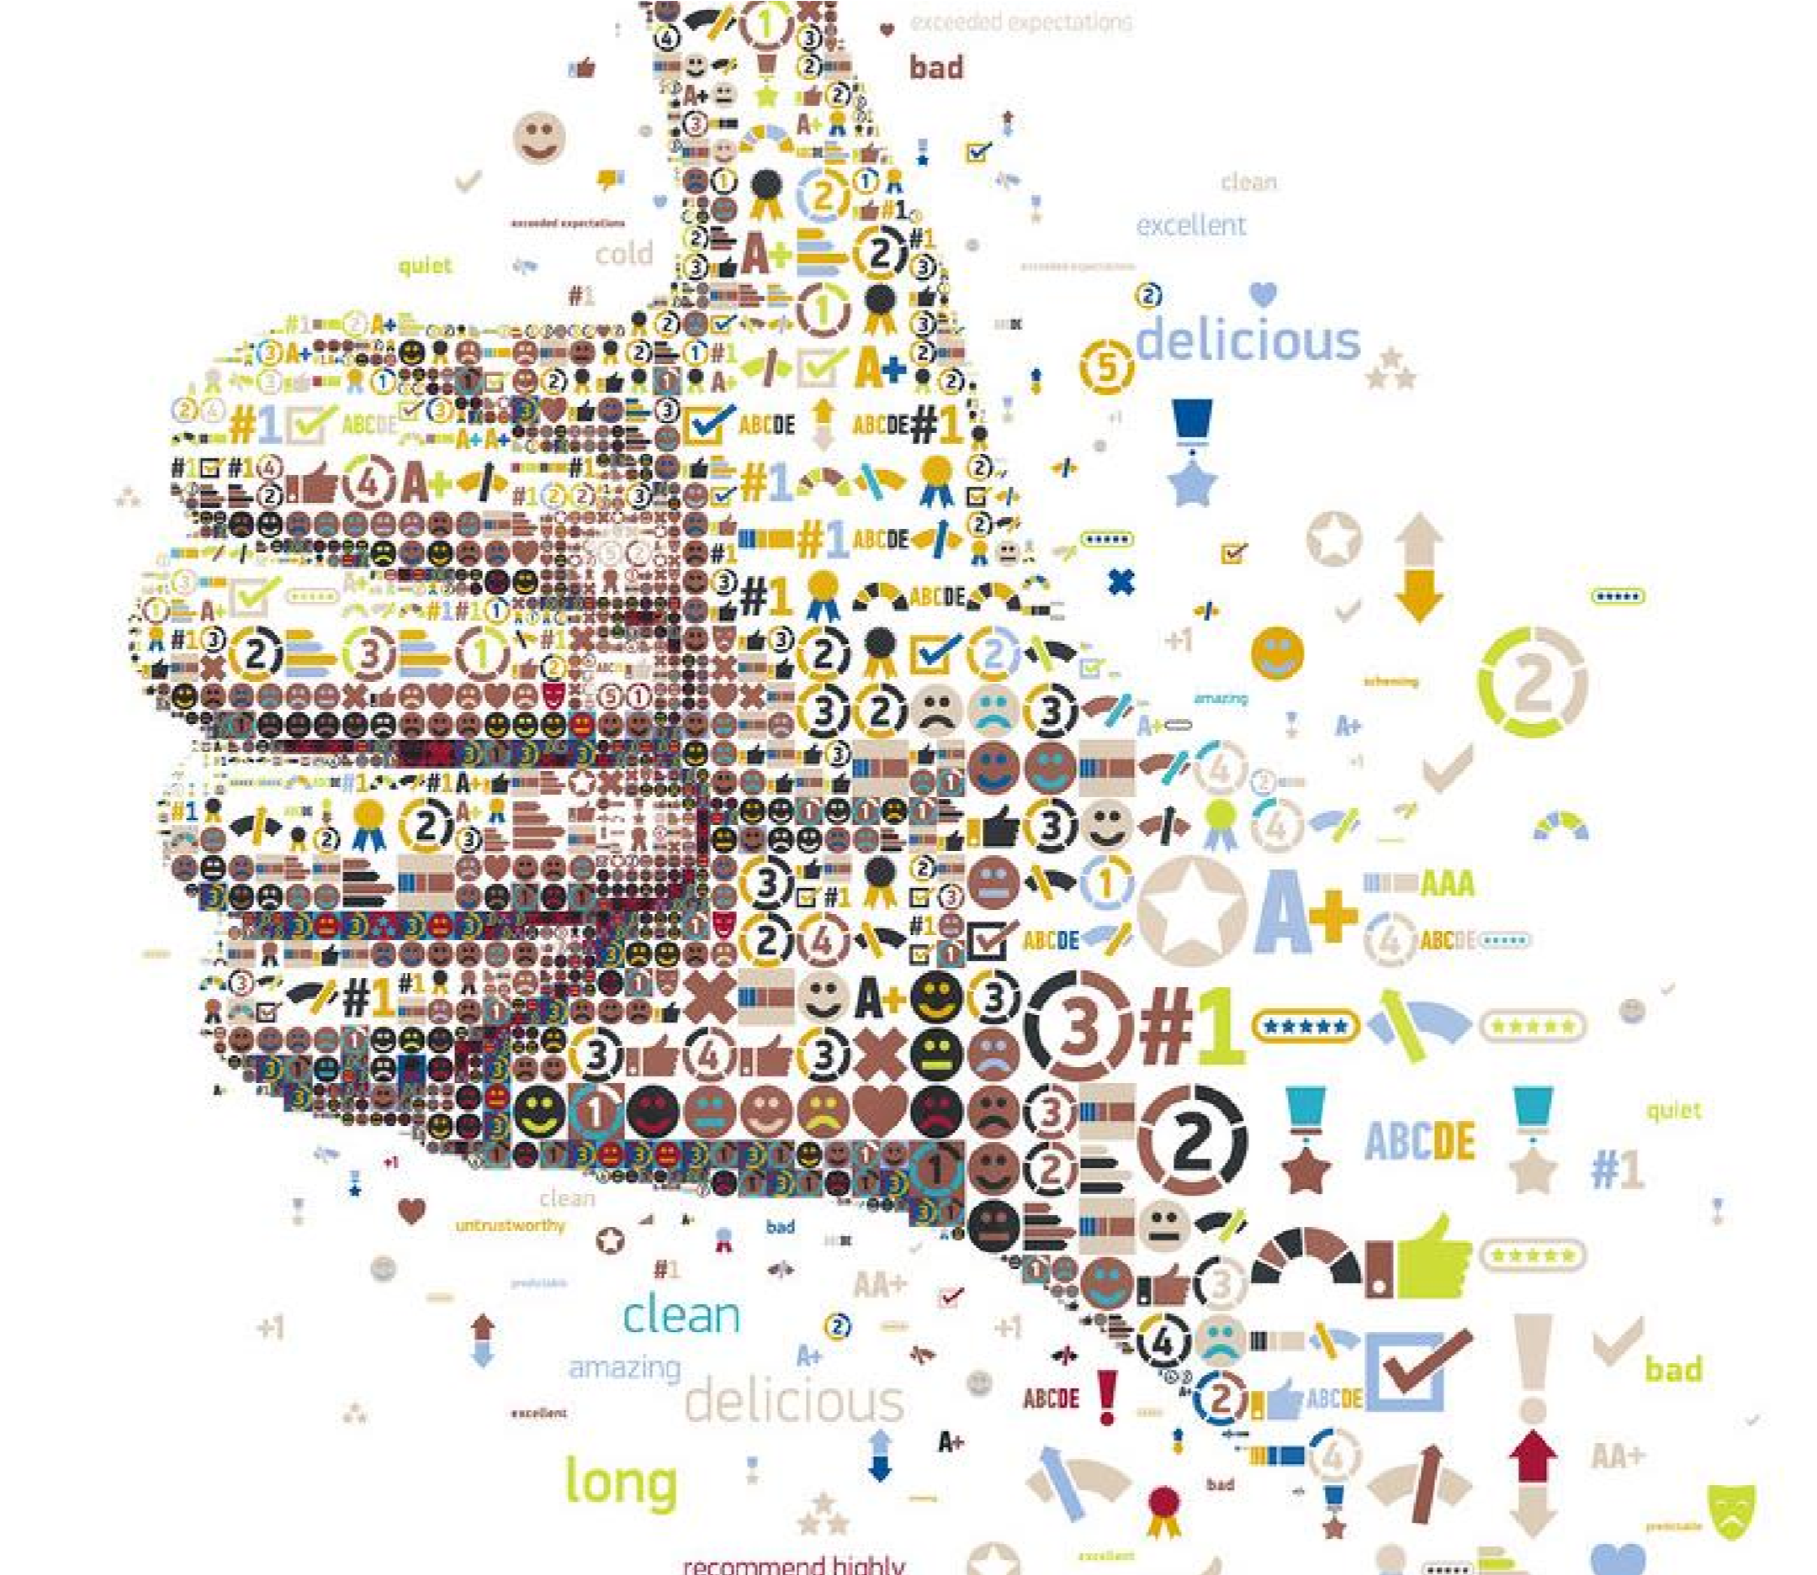

|  |
| --- |
| Real Time Sentiment Analysis  Machine Learning |
| 8/5/2024 |

Real Time Sentiment Analysis

By

Alishba Shah

Faizan Lakho

Habibullah

To

Dr. Gul sher

Contents

*Abstract*............................................................................................................................................. 3

1. **Introduction** .............................................................................................................................. 4
2. Related Work ............................................................................................................................. 4
3. Problem Statement .................................................................................................................... 5
4. Proposed Methodology ............................................................................................................. 5

Data Collection and Integration...................................................................................................... 5

Text Processing and Analysis .......................................................................................................... 5

User Interface Development ...................................................................................................... 5

Deployment and Maintenance ....................................................................................................... 6

1. Objectives .................................................................................................................................. 6
2. System Requirements ................................................................................................................ 6

Hardware Requirements ................................................................................................................ 7

1. Technology Stack ....................................................................................................................... 7 8. Backend Development ............................................................................................................... 7
2. Frontend Development ................................................................. **Error! Bookmark not defined.**
3. Conclusion ............................................................................................................................. 8

Appendix ........................................................................................................................................... 8

# Abstract

*The real time sentiment Analyzer Application is designed to improve the way businesses, researchers, marketers, and individuals analyze and interpret sentiment from content. By addressing critical gaps in accuracy and user-friendliness in existing sentiment analysis tools, this application enhances decisionmaking processes across various domains including marketing, customer service, and social media monitoring. Utilizing advanced natural language processing (NLP) along with powerful visualization tools, the application promises to deliver actionable insights with high precision. This project documentation outlines the problem statement, objectives, technology stack, and a comprehensive development plan aimed at creating a scalable, reliable, and easy-to-use sentiment analysis tool that integrates seamlessly with business social media account such as facebook.*

# Introduction

In today’s data-era, understanding the importance of human emotions expressed in text is not just a technological endeavor but a crucial business strategy. The real time Sentiment Analyzer Application is engineered to meet this growing need by providing an advanced tool for analyzing textual sentiment in real-time. This comprehensive application combines the latest advancements in machine learning (ML) and natural language processing (NLP) to interpret sentiments expressed across various text-based mediums.

The application is designed to cater to a wide array of users ranging from businesses seeking to understand consumer sentiment, marketers aiming to gauge brand perception, researchers analyzing data trends, and individuals interested in exploring emotional content in written communications. Its core functionality extends beyond mere word recognition, delving into the contextual and emotional significance of language used in social media posts, customer reviews, corporate communications, and even textual content captured from images.

A standout feature of the real time Sentiment Analyzer Application is its ability to integrate seamlessly with social media platforms via APIs, notably with Facebook, to directly analyze comments and posts. This real-time analysis capability allows organizations to react swiftly to customer feedback, manage PR crises more effectively, or capture market sentiment trends as they unfold. Furthermore, the application breaks new ground by incorporating Optical Character Recognition (OCR) technology. This feature enables the extraction and analysis of text from various image formats, broadening the scope of data sources available for sentiment analysis. Whether it's scanning printed documents, interpreting handwritten notes, or analyzing graphical content on social media, the OCR integration ensures that no valuable data is overlooked. The Sentiment Analyzer Application is not just a tool but a solution designed with the user in mind. It features a highly intuitive interface that simplifies the complex processes of data ingestion, analysis, and visualization. Users can expect a seamless experience from data input to insight generation, with actionable results presented through clear, interactive visualizations.

By addressing the limitations present in current sentiment analysis tools—such as accuracy issues and user interface complexity—the Sentiment Analyzer Application is set to revolutionize how we understand and utilize sentiment data. This application promises to empower its users with accurate, timely, and actionable sentiment insights, thereby facilitating informed decision-making across various spheres of business and research.

# Related Work

The field of sentiment analysis has evolved significantly, transitioning from basic lexicon-based methods to advanced machine learning models and deep learning architectures like CNNs, BERT, and RoBERTa. These developments have enhanced the ability to understand complex language nuances and the context within which sentiments are expressed. Research has particularly focused on adapting these technologies for social media, where the informal and dynamic nature of text presents unique analytical challenges. Despite advancements, many existing tools still lack in areas such as real-time analysis capability, user-friendliness, and the ability to handle multimedia content effectively. The integration of Optical Character Recognition (OCR) technology is also emerging, allowing sentiment analysis to expand beyond traditional text sources to include text extracted from images and offline materials. However, gaps remain, particularly in providing an intuitive, flexible, and comprehensive tool that can seamlessly integrate with platforms like social media for live sentiment tracking. The Sentiment Analyzer Application addresses these needs by combining cutting-edge NLP techniques with a user-centered design, aiming to set a new standard for accuracy, ease of use, and comprehensive analytical capabilities in sentiment analysis.

# Problem Statement

Many current tools struggle with the nuanced understanding of language, failing to accurately determine sentiments where context and cultural subtleties play crucial roles. Misinterpretations can lead to misguided decisions, particularly in sensitive contexts like customer feedback and market analysis. With the rapid pace of digital interactions, the ability to perform sentiment analysis in real-time is crucial. Delayed sentiment assessments can result in missed opportunities for timely engagement or crisis mitigation. As text data is not limited to plain text files but also embedded in images and videos, most tools do not support extracting text from these formats. This limitation restricts the analysis to a smaller subset of available data, potentially overlooking critical insights. The technical complexity of implementing and operating most sentiment analysis tools often requires specialized knowledge, making them inaccessible to non-expert users who could benefit from their capabilities.

# Proposed Methodology

## Data Collection and Integration

Utilize APIs to fetch real-time data from platforms like Facebook, enabling the analysis of live comments and posts. This will require authenticating and maintaining secure connections to these platforms.

Implement OCR capabilities to extract text from images, allowing the system to analyze sentiment from non-traditional text sources such as photos, scanned documents, and infographics.

## Text Processing and Analysis

Standardize the input text data by cleaning and normalizing it, which includes removing noise such as special characters, irrelevant symbols, and correcting common textual errors.

Apply advanced NLP techniques to parse and understand the structure of sentences, using libraries such as NLTK, spaCy, or TextBlob. This will involve tokenization, part-of-speech tagging, and dependency parsing to extract meaningful patterns.

Develop a hybrid model combining machine learning algorithms and deep learning architectures to accurately determine sentiment polarity. This model will be trained on a diverse dataset to enhance its understanding of various linguistic nuances and context.

### User Interface Development

Created a responsive and intuitive web interface that allows users to easily input text, upload images, and view sentiment analysis results. The interface will be designed to accommodate users with varying levels of technical expertise.

Integrate visualization APIs like Matplotlib or Plotly to generate dynamic graphs and charts that represent sentiment trends and distributions, making the data accessible and actionable for users.

## Deployment and Maintenance

Deploy the application on a cloud platform to ensure scalability and reliability. This will involve setting up servers, databases, and ensuring adequate security measures are in place.

Regularly monitor the system performance and user feedback to make necessary adjustments. Update the system to incorporate new features, improve existing functionalities, and adapt to emerging sentiment analysis trends.

# Objectives

The main objectives of the Sentiment Analyzer Application are:

* Create an intuitive interface that simplifies the process of inputting data and interpreting sentiment analysis results for users with varying technical skills.
* Implement advanced NLP algorithms to accurately determine sentiments by considering the context and subtleties of language.
* Provide capabilities for real-time sentiment analysis to allow users to respond swiftly to emerging trends and sentiments.
* Integrate OCR technology to analyze textual content from images and videos, and develop APIs for seamless integration with social media platforms like Facebook.
* Design the application to handle large volumes of data efficiently, maintaining performance during peak usage.
* comprehensive visualizations of sentiment analysis results, making them easy to understand and actionable for decision-making.
* Incorporate user feedback mechanisms to continually refine and enhance the application, adapting to new challenges and advances in technology.

# System Requirements

The Sentiment Analyzer Application requires a robust system architecture to ensure effective performance and user satisfaction. Below are the detailed system requirements categorized by software, hardware, and third-party integrations:

* Compatible with Windows 10/11, macOS, and Linux distributions to ensure broad accessibility.
* Version 3.8 or later, providing the core programming environment with extensive support for libraries and frameworks utilized in the project.
* NLTK, spaCy, or TextBlob for core text processing and sentiment analysis functionalities.
* Integration of a Python-compatible OCR library such as Tesseract for converting images to text.
* Flask or Django for developing the backend, ensuring easy management of routes, databases, and server-side logic.

## Hardware Requirements

* Intel i5 or equivalent, with multi-core processing capabilities to handle computational demands.
* Minimum of 8GB to ensure smooth multitasking and processing.
* At least 100GB of free disk space for application files, databases, and logs.
* Reliable internet connection for accessing APIs, cloud services, and real-time data processing.

# Technology Stack

* Python with Flask or Django frameworks.
* HTML, CSS, and JavaScript.
* Integration of a Python-compatible OCR library.
* Use of Facebook's Graph API.

# Backend Development

The backend development of the Sentiment Analyzer Application is pivotal in ensuring that the tool functions efficiently, processes data accurately, and scales effectively to handle high volumes of user requests. The development plan for the backend architecture is structured to support robust sentiment analysis capabilities while ensuring high performance and security. Here are the key components and steps involved in the backend development process:

* Python will be used due to its extensive support for data manipulation and availability of libraries for natural language processing and machine learning.
* Flask or Django will be chosen based on their scalability and ease of integration with other services. Flask offers simplicity and flexibility, making it suitable for smaller, lighter backends, whereas Django provides a more robust framework with built-in features suitable for larger applications.
* Design and implement RESTful services to handle requests between the frontend and the backend efficiently. These APIs will facilitate operations such as submitting text for analysis, fetching sentiment analysis results, and managing user data.
* Implement secure authentication mechanisms to protect access to the application’s data and services. OAuth2 might be used for securing API endpoints, ensuring that only authorized users can access certain functionalities.
* Integrate with NLP libraries like NLTK, spaCy, or TextBlob to process and analyze textual data. These libraries will be used for tasks such as tokenization, part-of-speech tagging, and sentiment analysis.
* Integrate an OCR library such as Tesseract to enable text extraction from images, expanding the types of data that users can analyze within the application.
* Develop systems to ingest and process data from various sources, including direct user inputs, file uploads, and integrated social media platforms.
* Implement database schemas that efficiently store user data and analysis results, allowing for quick retrieval and manipulation of data.

* Write comprehensive unit tests for all components to ensure individual modules function correctly.
* Conduct integration testing to verify that different components of the application work together seamlessly.
* Perform stress tests to ensure the application can handle high volumes of requests without performance degradation.

# Conclusion

The development and deployment of the Sentiment Analyzer Application mark a significant advancement in the field of sentiment analysis. This application is designed to meet the growing demand for a robust, intuitive, and efficient tool that can analyze and interpret sentiments expressed across various textual data sources in real time. By integrating cutting-edge natural language processing (NLP) techniques, optical character recognition (OCR), and social media APIs, the application offers a comprehensive solution that surpasses the capabilities of existing tools. The Sentiment Analyzer Application addresses critical gaps in the market, such as the need for greater accuracy, real-time analysis capabilities, and user-friendly interfaces that do not require advanced technical expertise to navigate. Its development is a response to the specific challenges identified through extensive market analysis, including the need for better data integration, scalability, and the ability to handle diverse and voluminous data sets efficiently. Looking forward, the Sentiment Analyzer Application is positioned not only as a tool but as a platform that can evolve with advancements in technology and shifts in market demands. Continuous improvement, driven by user feedback and technological innovation, will ensure that the application remains at the forefront of sentiment analysis technology. It will empower businesses, researchers, marketers, and individual users to make informed decisions based on accurate and timely sentiment analysis, ultimately enhancing their operational effectiveness and competitive edge in the market.

In conclusion, the Sentiment Analyzer Application is set to redefine how sentiment is analyzed and utilized, making it an indispensable tool for anyone looking to harness the power of textual analysis to gain deeper insights into human emotions and opinions.

# Appendix

